O.O. Gonchar¹, I.M. Goncharenko^{1,2} (Times New Roman, Bold, 10 pt, centered)

TITLE IN CAPITAL LETTERS (TIMES NEW ROMAN, BOLD, 10 PT, CENTERED, UP TO 12 WORDS)

¹ S.P. Timoshenko Institute of Mechanics of the National Academy of Sciences,
P. Nesterov Str., 3, 03057, Kyiv, Ukraine;
e-mail: email@inmech.kiev.ua (Times New Roman, Italic, 10 pt, centered)
² National Technical University of Ukraine "Igor Sikorsky Kyiv Polytechnic Institute
", Beresteyskyi Ave. 37, 03056, Kyiv, Ukraine

The main text should be typed in Times New Roman font, 10 pt, width alignment, and the indentation of the first line of all paragraphs, starting with the first - 0.6 cm. The volume of the annotation is 1-2 full pages, typed with single spacing in the Word text editor version no lower than MS Word 2003. The formulas have to be typed using the MathType editor.
, (1)
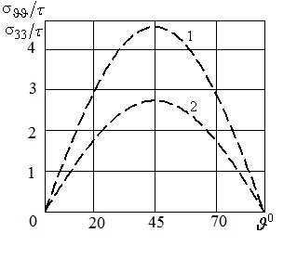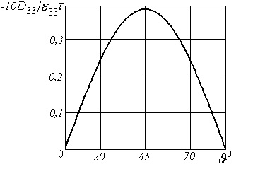
a b
Fig.1.

Figures must be made in JPG, JPEG, and TIF formats in black and white with a resolution of at least 600 dpi. Figures prepared in the Word text editor are not allowed. All explanations of the figures should be included in the text.

KEYWORDS: keywords. (no more than 2 lines, Times New Roman, 8.5 pt)

The list of references is provided at the end of the annotation in alphabetical order (Times New Roman, 8.5 pt). Sources published in Latin are listed alphabetically after sources published in Cyrillic. References to cited sources should be indicated in the text in square brackets (for example, [2, 11 – 13]). Examples of representation of the main types of sources are given below.

1. Guz A.N. For the 100th Anniversary of the S. P. Timoshenko Institute of Mechanics of the National Academy of Sciences of Ukraine (NASU) // Int. Appl. Mech. – 2018. – 54, N 1. – P. 3 – 33.
2. Guz I.A., Rodger A.A., Guz A.N., Rushchitsky J.J. Predicting the properties of nanocomposites with brush-like reinforcement // Carbon Nano Tubes New Engineering Technologies: Abstracts of the Int. Conf. CNTNET 07, University of Cambridge, Trinity College, United Kingdom. (Cambridge, 10-12 September 2007). – Cambridge, 2007. – P.29.
3. Timoshenko S.P., Gere J.M. Mechanics of Materials. – New York: Van Nostrand Reinhold Company, 1972. – 670 p.

